FFSD PROJECT REPORT

Project :Online Vehicle Parking Reservation System

Abstract

The Online Vehicle Parking Reservation System is a comprehensive solution aimed at streamlining the parking process for users, parking lot owners, and administrators. The system allows users to reserve parking slots, make transactions securely, and manage their bookings. Parking lot owners , provide visual information, and manage slot availability in real-time. The admin plays a crucial role in overseeing the entire system and assisting users and parking lot owners. The Online Parking Reservation System is designed to address the challenges associated with parking in urban environments. By incorporating user-friendly features, secure transactions, and an efficient administration panel, this system aims to enhance the overall parking experience for users. The project aligns with the goals of the Full Stack Development course by integrating front-end and back-end technologies to create a robust and practical solution.

Expected outcomes

1) User-Friendly Interface: A simple and intuitive interface ensures ease of use for both users and administrators.

2)Efficient Parking Management: The system streamlines parking space allocation, reducing congestion and improving overall efficiency.

3) Transparent Transactions: Users can monitor their wallet transactions, ensuring transparency and accountability.

Implementation Plan

***1) Version Control:***

* Set up a version control system (e.g., Git) for collaborative development.
* Create a shared repository to manage code changes.

2) ***Frontend Development:***

a. Homepage and Navigation:

* Create a basic HTML structure for the homepage.
* Add a navigation bar with links to Home, About, Contacts, Sign In, and Sign Up.

b. User and Parking Lot Owner Registration:

* Design and implement registration forms using HTML.
* Use JavaScript for form validation before submission.

c. User Wallet:

* Develop a simple wallet interface using HTML and CSS.
* Implement basic functionality for adding virtual currency using JavaScript.

d. Parking Slot Booking:

* Design a form for users to input location, vehicle type, and timing.
* Use JavaScript to display available and unavailable slots dynamically on a map.

e. Cancellation and Refund:

* Create a cancellation interface with password protection.
* Implement dynamic cancellation charges and refund the remaining amount to the user's wallet.

3) ***Backend Development:***

a. User and Parking Lot Owner Registration:

* Set up a basic server using Nodejs and Express.js for user and parking lot owner registration.
* Implement basic database storage (MongoDB, MySQL) for user and parking lot owner data.

b. User Wallet and Transactions:

* Develop server-side logic for virtual wallet management.
* Implement secure transaction handling on the server.

c. Parking Slot Booking:

* Create server-side logic for handling slot availability.
* Manage booked slots and deduct the amount from the user's wallet.

d. Admin Control:

* Set up an admin interface on the server for live monitoring and slot management.

4) ***Integration:***

* Connect the frontend and backend .Ensure seamless communication between the user interface and server.

5) ***Testing***

* Conduct unit testing for individual components. Perform integration testing to identify and resolve any communication issues.

6) ***Deployment***

* Choose a hosting platform for deployment
* Deploy the application and ensure all features work as expected in a live environment.

**Flowchart**

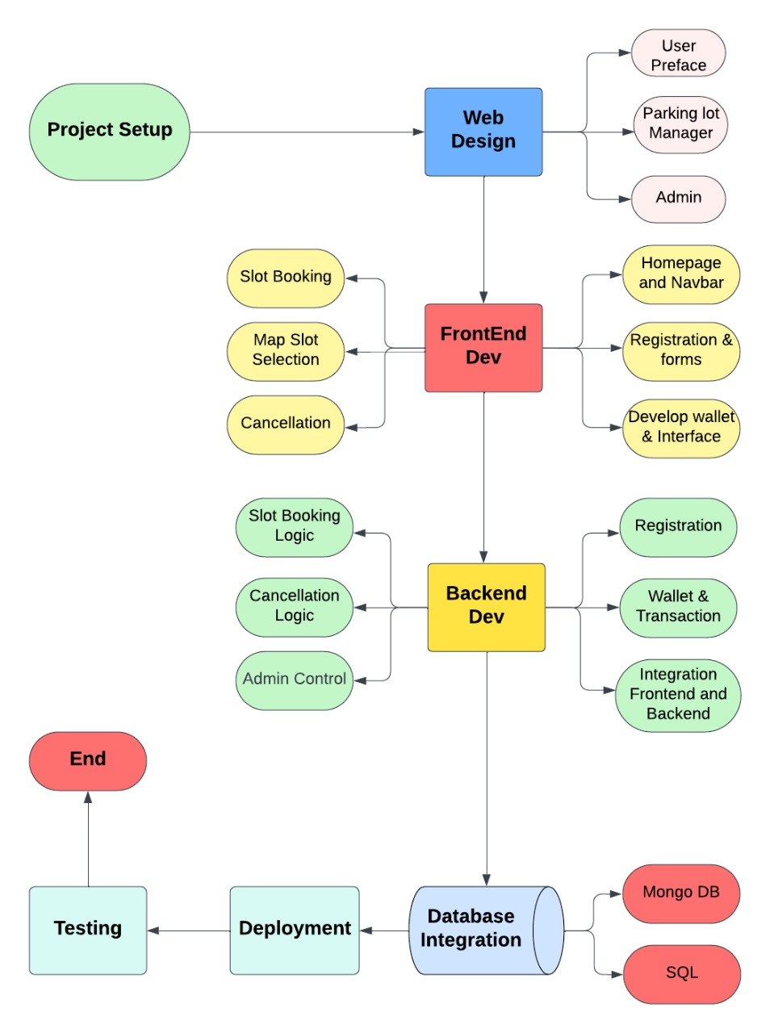

**Individual Expected Contribution:**

1.***Sahil Kasare (S20220010191)***

*Comprehensive User Interface and Layout Design*

*Home Page : Responsibilities (Frontend+ Backend) *

- About Us, Contact, Login, Sign Up

- Storing Sign Up details into database (Add new user to all prefaces).

- Redirecting to respective dashboards(User, Admin, Parking Manager) based on login details.

2. ***Sushant Gadyal (S20220010218)***

*User Preface: Responsibilities (Frontend+ Backend) *

- Booking Form (for date, time, and location selection), Parking Slot Map

- Price Estimation (based on selected date and time)

- Payment Integration for wallet(Frontend)

- Current Bookings (with details of upcoming bookings)

3. ***Yadnyesh Badgujar (S20220010247)***

*Manager Preface:*

Responsibilities (Frontend + Backend)

- Real-Time Booking Dashboard

- Parking Lot Details (capacity, location, pricing, availability)

- Booking Management (view, modify, and cancel bookings)

- Revenue Statistics

*Common Components (Reusable across pages):*

- Header/Footer for navigation

- Alerts (system-wide alerts)

4. ***Vighnesh Barage (S20220010033)***

*Admin Preface:*

Responsibilities(Frontend + Backend)

- Overview Dashboard (with statistics and summary of all parking lots)

- Parking Lot Management

- User Management (view and manage user details)

- Manager Management

- Booking History

- Revenue Reports

5. ***Hrishikesh Dongre*** ***(S20220010083)***

*Parking Slot Reservation*

Responsibilities (Frontend+ Backend)

-Logic for Reservation, Updating, Retrieval and Dynamic Display of parking slot based on date, time and vehicle type.

*Wallet Management:*

Responsibilities (Frontend+ Backend)

-User ,Admin, Parking Lot manager Wallets

- Wallet Balance and Transactions, Add Funds to Wallet

- Transaction History , Security Measures

**Team Members:**

1. Sahil Suresh Kasare (S20220010191)
2. Vighnesh Suryakant Barage (S20220010033)
3. Sushant Gadyal (S20220010218)
4. Yadnyesh Avinash Badgujar (S20220010247)
5. Hrishikesh Dongre (S20220010083)

**Software Environment:**







